Here’s a look at how the system compared to buying and holding the S&P 500 index over the past 50 years, showing all data and then one decade at a time. In all charts, the red line represents the equity curve for buying and selling the index based upon signals from the system. The dark blue line represents the equity curve for buying and holding the index throughout the decade. The first chart shows all data, starting at 1000 for both approaches. Each decade chart starts at 1000 for both approaches.

Here’s the chart for 1960-2009. It probably would have been better to show this in log format. The key points here are how the system avoided the last two big downturns.

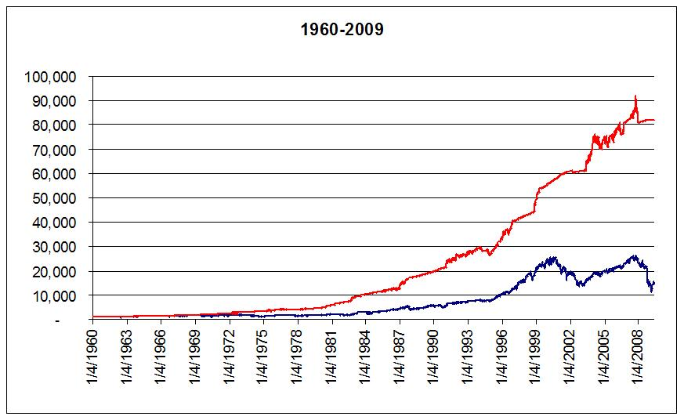

Here’s the first decade in the test period. Both approaches stayed pretty much together, but the system avoided three market downturns and ended up doing better overall than the buy and hold.

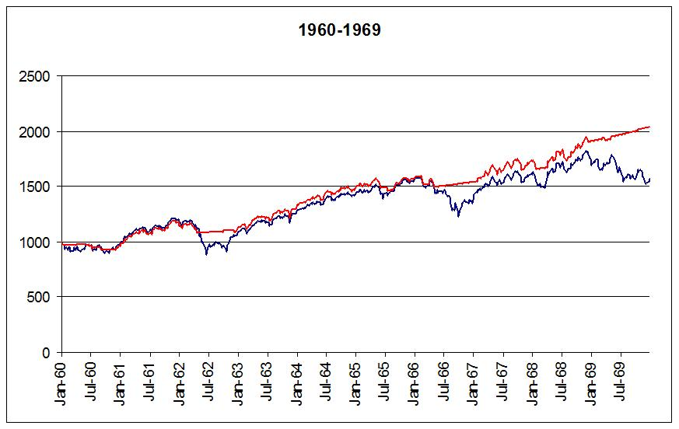

Here’s the chart for the 70s. The system missed the bear market of 1974, and did pretty well during those later years when rates were high and stocks were flat.

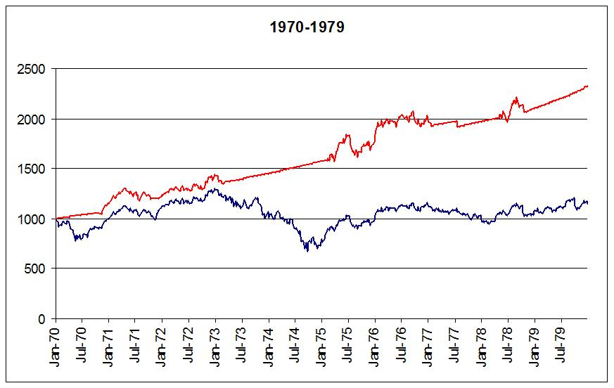

During the 1980s, there was a downturn in the early part of the decade, and then the big crash in 1987. The system missed both of these.

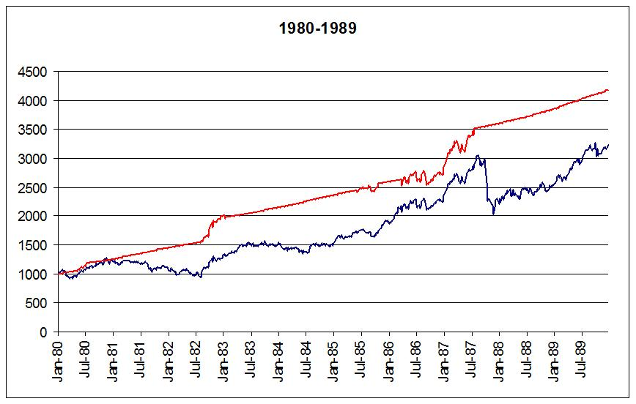
Ah, the 1990s. This is the only decade when the market actually performed better than the system. Stocks were soaring in the latter part of the decade, and the system’s risk aversion kept it in cash much of the time.

Parenthetically, I started using the system with real money in January, 1995. I was fairly comfortable until early 1997 when the market left me behind, but I stayed with the system. I felt a little redeemed in late 1998 when the market dropped while I was in cash.

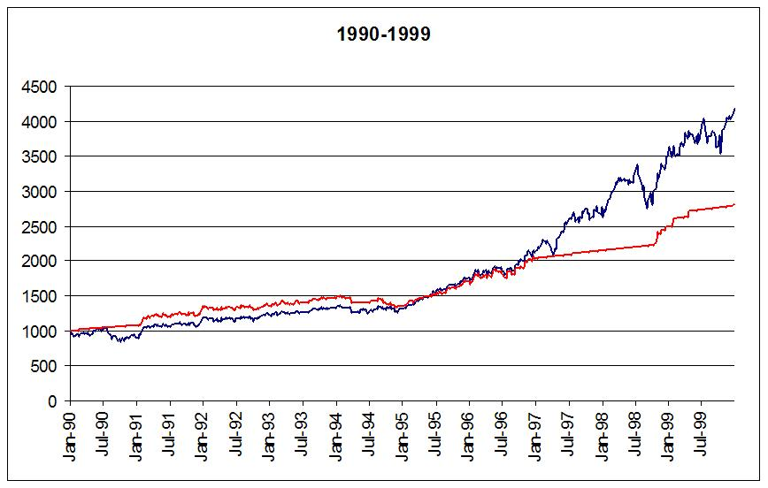
And here’s the current decade. The system’s equity curve moves up, but nothing too exciting until you see how the market did. Missing those two big drops was nice. The flatness of the system’s equity curve was caused by the low treasury yields during this time.

